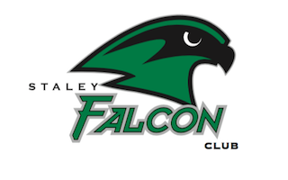
Staley Falcon Club
Parent Representative Contact Form
2020-2021

Your student is currently in an activity that requires your parent representative to contact you regarding volunteering and overall communication. Please list your preferred means of communication.

Name of Activity/Class ____________________________________________

Student(s) Name ____________________________________________

Please Print

 | Name | Email Address | Phone #

Parent Signature ____________________________________________________

