Personal Information

Name: _______________________________________ H.S. Student ID # ___________

Address: ________________________________________________________________
Street City Zip Code

Home Phone: ____________________________ Cell Phone: ______________________

Email Address: __________________________________________________________

College/Technical School: __________________________________________________

1) Parent/Legal Guardian Name: _____________________________________________

Address (if different than above): ____________________________________________

2) Parent/Legal Guardian Name: _____________________________________________

Address (if different than above): ____________________________________________

Who is financing your education? ____________________________________________

List other sources of financial aid, including scholarships or grants received to date (use additional pages if necessary):

________________________________________________________________________

________________________________________________________________________

Are you a Falcon Club member? _____________________________________________

Have you volunteered or contributed to the Falcon Club and if so how? ______________

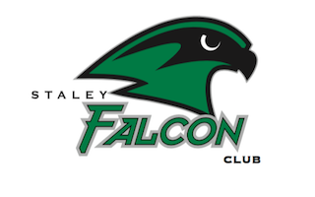

Application

Class Rank ____________ GPA_____________

On a separate piece of paper please type your answers to the following.

1. List high school activities. Include at least two different extracurricular activities or clubs, such as sports, music, theater, forensics, etc.

2. Describe your interests and activities outside of schools, including hobbies and/or community interests (scouting, volunteering, etc.).

3. List special honors or recognitions you have received, as well as leadership positions you have held at school or in the community.

4. Describe your paid work experience, if you have any.

5. In 250 words or less please let us know what volunteering means to you.

Your application must include the following materials:
- Both pages of this application including personal information and application
- Additional pages responding to the 5 questions above
- Community Service Record

Incomplete applications will NOT be considered. Please include all materials.

Signature of Applicant: ___________________________ Date: __________________

Due to COVID-19, we aren’t able to accept applications via mail.

Please email your application to staleyfalconclub@yahoo.com

All applications must be received by 5 p.m. on April 15th, 2020.

